
Elementary Chemistry Laboratory
Chem V20L | CRN 70927 | Online
Instructor Information

Class Meetings
W 10:00 am - 12:50 pm
@Zoom

Course Units
1.0 (3 hours of lab + 1 – 4 hours outside of class per week)

Prerequisites
MATHV01 or MATHV01E or MATHV11B or 1 year of high school beginning algebra with a grade of C or better

Name: Howard Han
E-mail: hhan@vcccd.edu
Office Hours: T 02:00 pm – 04:00 pm @ SCI-320
R 10:00 am – 11:20 am @ SCI-320
R 02:00 pm – 04:00 pm @SCI-320
Contact Hours: Monday-Thursday, you can expect me to respond to email within 3 hours. Messages and submissions posted after 11 pm on Thursday may not reach the instructor until Monday of the following week.

Class Information
This course is designed to work with its lecture component, CHEM V20, to be an introduction to laboratory techniques. The experiments illustrate typical chemical reactions, and the principles covered in lecture.

Course Required Materials
- A lab kit from Carolina Labs: [https://www.carolina.com/catalog/detail.jsp?prodId=582519
- Computer (for Canvas)
- Scanning device (a scanner or mobile device with a camera and scanner app)
- Either a microphone or webcam connected to your computer

On Campus resources:
Counseling | MESA | Library | Educational Assistant Center (EAC) | Extended Opportunity Programs and Services (EOPS) | Veteran’s Affairs Office
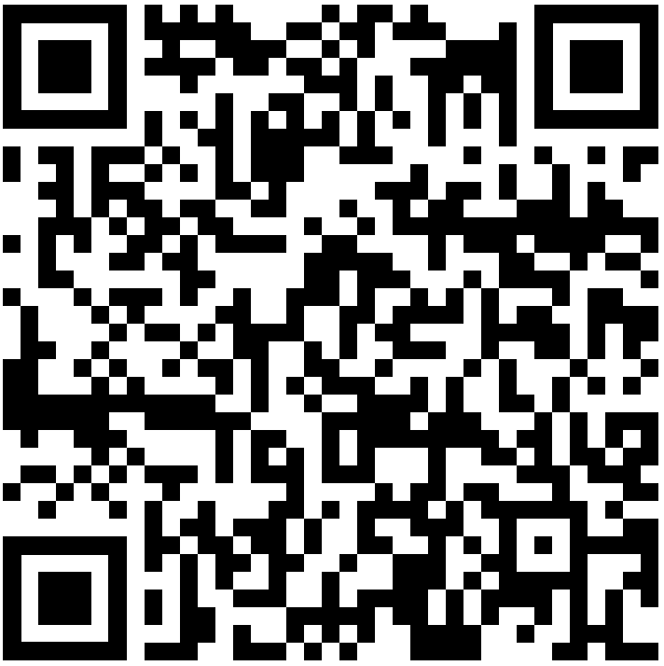 | 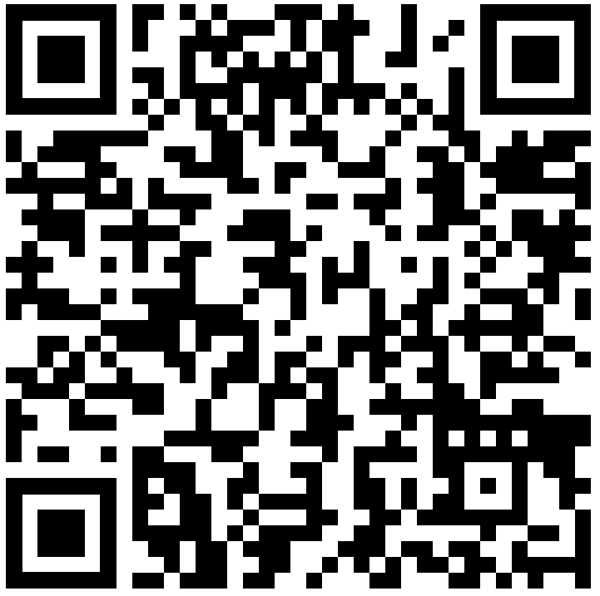 | 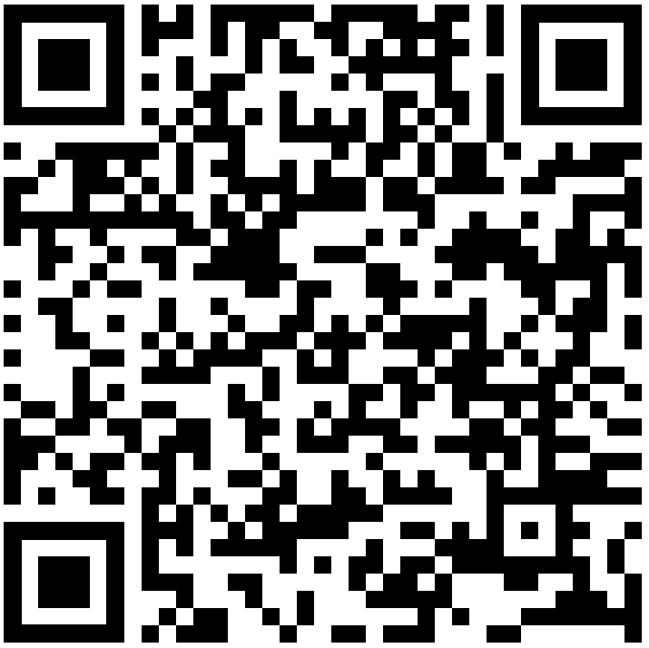 | 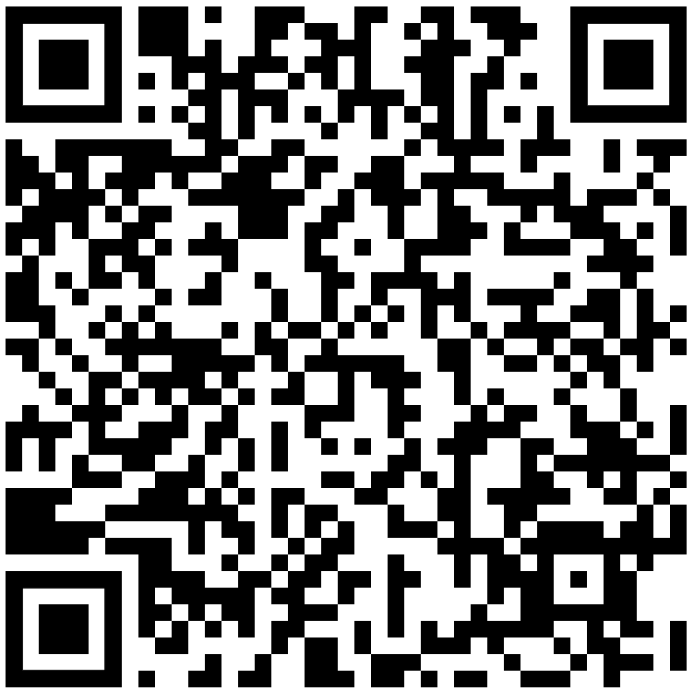 | 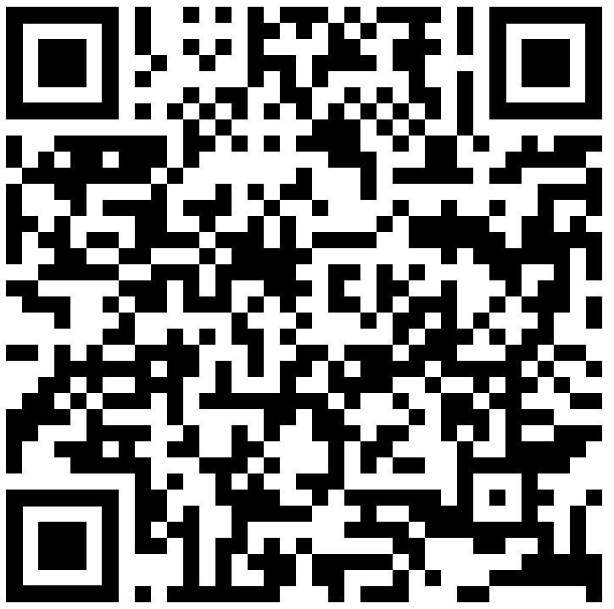 | 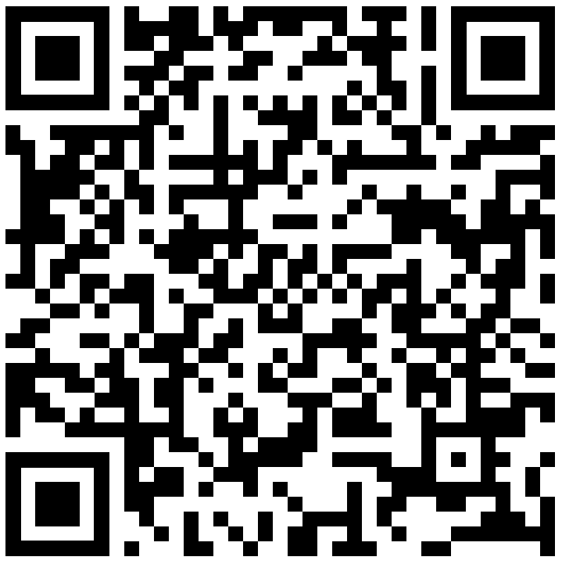


Course Objectives
Upon successful completion of this course, the student will be able to demonstrate the following measurable skills and abilities:
- Safely perform a variety of laboratory procedures.
- Use mass, volume, and length measuring devices and discuss their relative precision.
- Experiment with chemicals, including strong acids and bases, safely.
- Experiment with common laboratory equipment safely.
- Handle glassware correctly.
- Perform acid-base testing with litmus paper or other means.
- Apply the scientific method to chemistry problems, including developing hypothesis, hypothesis testing, and evaluation.

Student Learning Outcomes
By the end of this class, you will be able to:
- Perform laboratory techniques correctly following written protocols and using appropriate safety procedures.
- Evaluate sources of error, and their effect on experiment results.
- Perform careful and accurate laboratory measurements and correlate these measurements with scientific laws, and the properties of substances.

Core Competencies for the class can be found at:
See http://www.venturacollege.edu/faculty_staff/academic_resources/core_competencies/index.shtml

Course Format: Fully Online
This Chemistry course is fully online, designed to deliver a comprehensive and immersive educational experience entirely through digital means. The curriculum leverages the advantages of online learning, using the college's Canvas learning management system to provide a rich, interactive educational journey from the comfort of your home.
Key Features of the Course:
- Virtual Classroom Engagement: This course simulates the in-person classroom experience in a virtual environment. Engage with interactive simulations, virtual lab experiments, and live video discussions to understand the practical aspects of chemistry. Regular online meetings foster a sense of community and facilitate direct interaction with peers and the instructor.
- Comprehensive Online Resources: Through Canvas, you will have access to a wide array of digital resources, including digital copies of all class materials, online assignment submission, and real-time updates on grades and feedback. The platform serves as the central hub for course communications, ensuring you stay informed and connected throughout your learning journey.

Classroom Policy

Attendance:
This course combines at-home lab experiments with essential weekly Zoom sessions for guidance and understanding. Participation in these sessions is mandatory, as they cover lab procedures, safety protocols, and troubleshooting. Consistent engagement, timely submission of lab reports, and adherence to the schedule are required. Missing multiple sessions or assignments may lead to being dropped from the course. No make-up sessions will be offered, so regular attendance is crucial.

Equipment Policy:
You are responsible for maintaining the lab kit provided at the start of the semester. This includes keeping all equipment clean, in good working condition, and storing it safely after each use. The integrity of your at-home laboratory environment directly impacts your learning and safety. Carelessness in handling or failing to return the kit in its original condition will lead to grade deductions. Proper management of the lab kit is essential for a successful and safe laboratory experience.

A Note on Safety:
Even though experiments are conducted remotely, adherence to safety guidelines is paramount. Prior to each weekly Zoom session, you will receive specific instructions on preparing for the lab, including necessary safety measures and appropriate attire. It is imperative to follow these guidelines closely to prevent accidents. Any incidents or unsafe conditions encountered during your at-home experiments must be reported immediately during the Zoom sessions or via email. Creating a safe laboratory environment at home is critical for your protection and the successful completion of the course's laboratory component.

Academic Integrity:
Cheating or plagiarizing any assignment or examination is a serious breach of the Student Code of Conduct, strictly prohibited, and will result in a zero for that assignment and a report sent to the Behavioral Intervention Team and Student Services. Cheating includes, but is not limited to, talking, and using notes, references, or prohibited electronic devices during exams or quizzes, or any other advantage not available to all students in the class. Plagiarism includes copying homework assignments from online resources, tutors, or other students. Cheating, whether minor or major, is always unacceptable under any circumstances.

Grading Policy
Throughout the semester, the grades for all assignments will be posted on Canvas so that the current progress can be tracked by students. The final letter grade will be assigned based on the final point total of each student. Final grades will be considered conclusive and will not be rounded.

Evaluation of Student Performance:
- Lab Report (10 total)
  - Report: 40 pts
  - Photos From Experiments: 10 pts
- Lab Quiz (11 total)
  - Safety Quiz: 10 pts
  - Experiment Quiz: 20 pts
- Week 0 Assignments
  - Get-to-know-you survey: 10 pts
  - Document Scanning Practice Assignment: 10 pts
  - Lab Kit Purchase Confirmation: 10 pts
- Attendance
  - Attendance: 100 pts

Grade Scale:
- A: 90%-100%
- B: 80%-89%
- C: 70%-79%
- D: 60%-69%
- F: 59% or lower

Tentative Schedule
Week | Wednesday | Friday
1 | 9/11  Class Introduction  “Lab Safety” | 9/13  Quiz on Safety
2 | 9/18  Exp 1: “Measurement and Uncertainty” | 9/20
3 | 9/25  Exp 2: “Introduction to Graphing and The Scientific Method” | 9/27  Quiz 1 on Exp 1
4 | 10/2  Exp 3: “Exploring Density” | 10/4  Quiz 2 on Exp 2
5 | 10/9  Exp 4: “Fundamentals of Chromatography” | 10/11  Quiz 3 on Exp 3
6 | 10/16  Exp 5: “Exploring Physical and Chemical Properties” | 10/18  Quiz 4 on Exp 4
7 | 10/23  Exp 6: “Investigating Chemical Reactions” | 10/25  Quiz 5 on Exp 5
8 | 10/30  Exp 7: “Stoichiometry – Gravimetric Analysis” | 11/1  Quiz 6 on Exp 6
9 | 11/6  Exp 8: “Introduction to Molecules Bond Polarity and Hydrocarbons” | 11/8  Quiz 7 on Exp 7
10 | 11/13  Exp 9: “Finding the Percent of H₂O₂ In Commercial Hydrogen Peroxide” | 11/15  Quiz 8 on Exp 8
11 | 11/20  Exp 10: “Determination of Acetic Acid” | 11/22  Quiz 9 on Exp 9
12 | 11/27  Quiz 10 on Exp 10

